Images of our 2017 June Retreat at the Hedges on Blue Mtn. Lake, NY

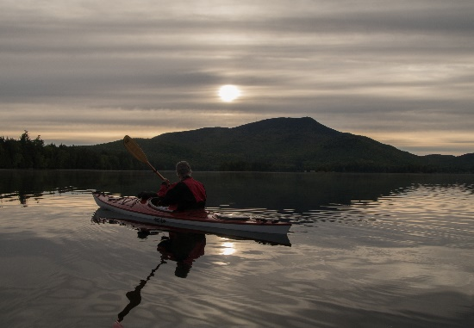This is a photo album of our stay at the Hedges on Blue Mtn. Lake, NY. Our June return holiday began with Jennifer, Dave, and Steve with their families joining us for an extended weekend. The album includes various photos of Blue Mountain Lake,and Eagle Lake, family activities there, the Wild Center in Tupper Lake, and the Aridondack Experience, formally, and correctly known as the Adirondack Museum. A lot of activities over the 12 days resulted in a photo or two.

And for the photos, click [The Hedges – June 2017](https://goo.gl/photos/aeoBcFN78iBHqGsa8).